Project 3B - Team1 Documentation

## Overview

Team 1 (ie The Wookie Workgroup) created a command line tool that decodes and encodes morse code (Project3B). The group consists of Daniel Mitchel, Joshua Neustrom, and Chen Wang.

The report gives an overview of our solution including the following

1. Assumptions
2. UML Class Diagram
3. Github Project Link
4. Algorithm
5. Error Handling
6. Known Issues
7. Efficiency Analysis of Algorithms
8. References

## Assumptions

1. * and – are valid morse code symbols
2. Use a Binary Search Tree for codes where * means go left, – means go right and the root data is empty
3. Codes for letters in morse code separated by spaces (example: -- **-)
4. Wookies rule

## UML Class Diagram

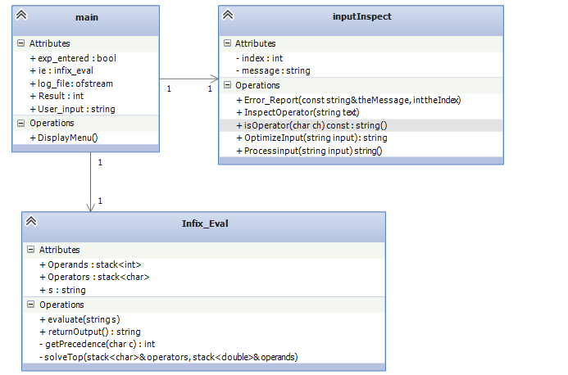

## Github Site

<https://github.com/WookieWorkgroup/Project3>

## Algorithm

1. Create table
   1. Open Morse Code file
   2. Read in letter
   3. Read in code
      1. * means go left
      2. – means go right
      3. Other symbol causes error
   4. Traverse tree to last part of the code
   5. Add node
      1. New node
      2. Set data
      3. Set final pointer
2. User Interface
3. Option 1 – Message to encode
   1. Read in letter
   2. Find letter in tree
   3. Add * for every left
   4. Add – for every right
4. Option 2 – Message to decode
   1. Tokenize code by spaces
   2. Look left for every *
   3. Look right for every –
   4. Get the letter
5. Option 3 – Display last result (last encoded or decoded message)
6. Option 4 – Clear input
7. Option 5 - Exit

## Error Handling

1. Bad Input – Error message retuned and user sent back to the main menu
2. Logging – Log.txt contains record of actions completed to help troubleshoot

## Known Issues

1. None so far

## Efficiency of Algorithms

1. Build – O(n) – one loop to place each letter
2. Encode/Decode – O(n) – one loop to encode/decode each letter

## References

1. Binary Tree from class Lectures used as a starting reference
2. The Force